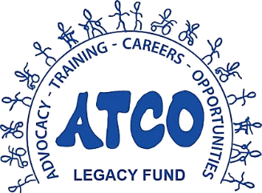
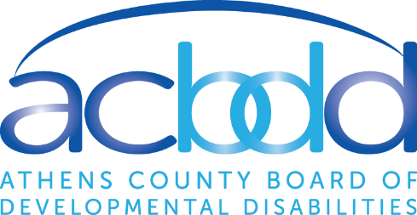

Spring 2021 Request for Proposals
Application Form
The Athens County Board of Developmental Disabilities (ACBDD), in partnership with the Athens County Foundation, is proud to announce the 2021 Spring Request for Proposals (RFP) for the ATCO Legacy Fund.
The Athens County Foundation is providing administrative support to the ATCO Legacy Fund's grant process. For questions or concerns, please email the Athens County Foundation at info@athensfoundation.org.
History:
ATCO, which was the ACBDD’s adult services program for nearly 50 years, was a much-beloved program that prioritized advocacy and inclusion for adults with intellectual / developmental disabilities (I/DD) in Athens County. In order to comply with a federal rule, ATCO closed in December 2018 after a three-year transition plan.
The ATCO Legacy Fund is designed to allow the ACBDD to carry on the compassion and philosophy developed at ATCO well into the future. As part of that process, stakeholders helped the ACBDD to identify certain elements from ATCO that could be sustained and enhanced while still remaining in compliance. Those conversations led to the creation of this fund in 2018.
Eligibility:
This program is designed to offer financial assistance to providers (agency and independent), organizations, and other community partners in Athens County that are interested in working towards integration and inclusive opportunities for adults or transition-age youth (13-21 years old) with I/DD. This cycle will also maintain a funding priority for COVID-19-related expenditures, as noted in the funding priorities section below.
Timeline:
This completed form is due May 26th by 5 p.m. The Athens County Foundation will convene a committee to review all proposals. The committee will then present selection recommendations – based on the criteria outlined below – to the ACBDD’s Superintendent.
Funding Availability:
The ACBDD has allocated $20,000.00 for this cycle. There is no minimum or maximum funding level per request.
Funding Priorities: Please select the funding classification you are seeking in this request. The structure and funding priorities are intentionally left broad and open-ended to ensure that needs of individuals with I/DD are met regarding inclusion, as well as during the COVID-19 public health emergency. *
☐ Promoting and supporting integration and inclusion for adults or students of transition age (13 to 21 years of age) with I/DD in Athens County. Examples could be (but not limited to): adaptive equipment that makes things accessible, supplies for projects, technology, memberships.
☐ Related to COVID-19, promoting the health and/or safety of individuals with I/DD or their staff. Examples could be (but not limited to): household supplies, PPE, or other fixed costs.

A. ORGANIZATION INFORMATION
Organization Name | Click or tap here to enter text.
Brief Description of your Organization (max 200 words)
Click or tap here to enter text.
Website | Click or tap here to enter text.

B. CONTACT PERSON INFORMATION
Name | Click or tap here to enter text.
Title/Position | Click or tap here to enter text.
Email Address | Click or tap here to enter text.
Phone Number | Click or tap here to enter text.

C. PROJECT INFORMATION
Proposal Title | Click or tap here to enter text.
Requested Amount | $ Click or tap here to enter text.
Proposed Use of Funds. Tell us about your project/program. Max 1000 words
Click or tap here to enter text.
Other Information you want to share with the Review Committee? Other information to help the committee make a determination, including the demonstrated need for the funds.
Click or tap here to enter text.

D. ATTACHMENTS. Please attach the following documents:
- Itemized Budget. Please attach the itemized budget of your project/program. If you need a template, please use this form from the Athens County Foundation: https://athensfoundation.org/wordpress/wp-content/uploads/2020/09/Grant-Application-Form-2020-Budget-Template.docx
- Other supporting documents that you want to include. Please attach other supporting documents that you want to include in your application.
- Please label the attachments with your organization's name in the file name, along with a description of the file. For example "ACBDD_ItemizedBudget.pdf."
E. AGREEMENT & SIGNATURE.
☐ I certify that the information provided are true and correct.

Applicants Signature X ________________________________________________

Please email completed form and attachments to info@athensfoundation.org.

Proposal Review Timeline
- May 26, 5 p.m. – Deadline for all submitted and completed proposals
- May 27 – June 11 – Review and scoring by Recommendation Committee (facilitated by the Athens County Foundation)
- June 11 – Committee provides recommendations to the ACBDD’s Superintendent
- June 22 – The ACBDD Board members officially review and approve grant fund recommendations at the regular June Board meeting
- After approval, before awarding of funds, the ACBDD will enter into a “contract” agreement with the winning applicants

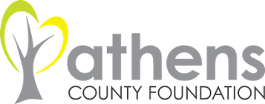
For additional information, contact:
Shayne Lopez, Programs & Outreach Coordinator
The Athens County Foundation
info@athensfoundation.org

